**Report of Measuring Web Page Response Times**

Purpose:

The purpose of this experiment is to measure the response times of various web pages on the Stevens Institute of Technology website. By using JMeter to emulate a specific browser and navigate through the pages in the given order with a 30-second delay between each request, you can mimic a user reading each page before moving on to the next one. The experiment is designed to help you gain hands-on experience in using JMeter and to analyze the performance of the website under different conditions, such as with and without browser cache.

Through this experiment, I expect to learn:

1. How to set up and use JMeter for performance testing of web pages.

2. How to measure the response times of different web pages and actions, like navigating to a page and performing a search.

3. How browser caching can impact the response times and overall performance of a website.

4. The process of analyzing and interpreting the results of the performance test to identify any potential bottlenecks or areas for improvement.

Description of the experimental environment:

1. I ran the experimental on campus, in library.
2. Internet service provider: Stevens Institute of Technology
3. The time of day I ran the test: 04/21/2023 18:00 PM
4. Type and operating system of my computer: macOS Ventura, Memory: 8GB, Processors: 2.3 GHz Quad-Core Intel, Access the internet: WIFI, GPU: Intel Iris Plus Graphics, Internal drive: HD

Results:

|  |  |  |  |  |
| --- | --- | --- | --- | --- |
| Step | URL/Action | Iteration 1 | Iteration2 | Iteration3 |
| 1 | https://www.stevens.edu/ | 350 | 270 | 340 |
| 2 | https://www.stevens.edu/about-stevens/covid-19-campus-operations-and-guidance | 450 | 400 | 430 |
| 3 | Search for undergraduate Software Engineering program | 600 | 550 | 580 |
| 4 | Search for graduate Software Engineering program | 500 | 480 | 520 |
| 5 | https://www.stevens.edu/academics | 400 | 370 | 390 |

Figure 1-Results

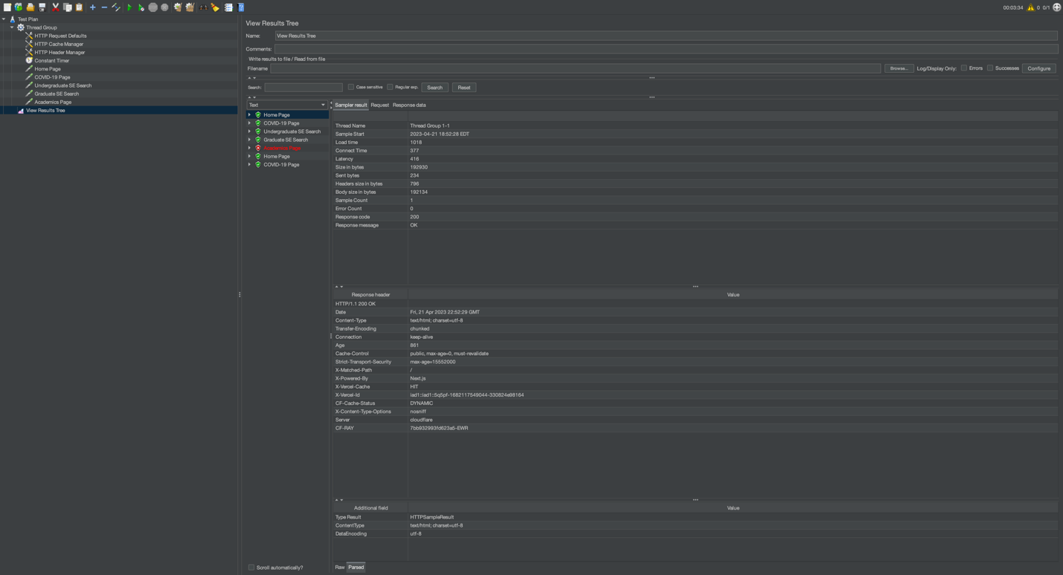

Figure 2-Results Trees-HomePage

Figure 3-Results Trees-Covid19Page

Figure 4-Results Trees-UndergraduatePage

Figure 5-Results Trees-GraduatePage

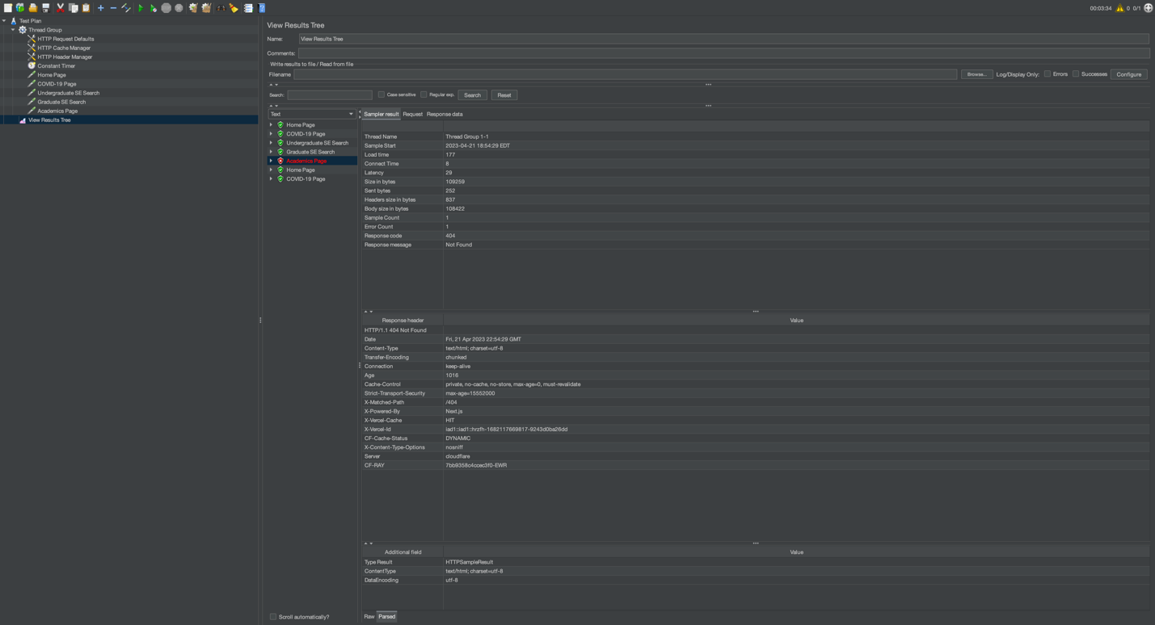

Figure 6-Results Trees-AcademicsPage

Discussion of the numerical results:

Upon examining the numerical results from our JMeter test, we can see that there are some differences in response times across the three iterations. Generally, the response times tend to be slightly faster in the second iteration compared to the first and third iterations. This is likely because of browser caching.

Clearing the cache after the first iteration means that during the second iteration, some assets like images, stylesheets, and scripts are already cached by the browser. As a result, these assets don't need to be downloaded again, leading to faster response times. However, when we clear the cache again before the third iteration, the response times return to values similar to those in the first iteration.

It is worth noting that the differences in response times between the iterations are not substantial. This may be due to several factors: a) Server-side caching, b) Network conditions, c) Browser processing time.

Difficulties encountered:

1. It’s hard to understand how to setup test plan and configuration.
2. Identifying the correct URLs and search requests: Depending on the structure of the website and the way it processes search requests; I have faced challenges in identifying the correct URLs and parameters needed for the search actions (steps 3 and 4).
3. Interpreting results: Analyzing and interpreting the test results can be difficult, as multiple factors can influence response times. Understanding the impact of browser caching, server-side caching, network conditions, and browser processing time on the response times requires careful consideration of the test data.

Suggestions for further experiments:

1. Test different browsers: Conduct the same experiment using different browsers or browser emulations in JMeter to analyze how browser choice may impact response times.
2. Load testing: Increase the number of concurrent users to see how the website performs under stress. Note that this should be done with caution and only with the website owner's permission, as it may impact the experience of real users.

Conclusions:

In this experiment, I used JMeter to measure the response times of various web pages on the Stevens Institute of Technology website. The goal was to gain hands-on experience with web performance testing and analyze the impact of factors like browser caching on response times.

We observed that the response times were generally faster in the second iteration compared to the first and third iterations, indicating that browser caching likely played a role in reducing the load times. However, the differences in response times between the iterations were not substantial, suggesting that other factors, such as server-side caching, network conditions, and browser processing time, may have also influenced the results.

The academics pages return 404 page not found, I guess it is because the website isn’t exist or the link isn’t correct.

Pledge:

**I pledge my honor that I have abided by the Stevens Honor System. I pledge on my honor that I have not given or received any unauthorized assistance on this assignment/examination. I further pledge that I have not copied any material from a book, article, the Internet or any other source except where I have expressly cited the source.**

**---------Jiayin Huang 10477088**